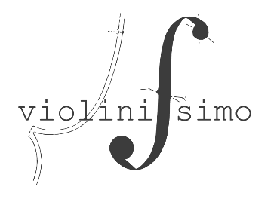
Annex 1. Application Form
the application is filled in electronic form

General information:

1. Surname, name

2. Country, city

3. Date of birth

4. Place of study (or place of work)

5. Phone number (preferably with WhatsApp)

6. E-mail

Achievements:

1. Participation in competitions (for the last 3 years)

2. Experience in concert performances (orchestras, conductors, halls)

Program:
(rule for the design of the program: composer, title of the composition, part (if necessary), opus, duration of the composition)

1 round (qualifying):

Link to the video recording for the first (qualifying) round:
*video must be recorded between December 2022 and July 2023

2 round, 1 part:

2 round, 2 part:

The following must also be attached to the application letter:
• scan of the applicant's main identification document (passport);
• a separate file with a creative biography (approximately 1000 characters);
• 3 color photographs in digital format with a resolution of at least 300 dpi, including one close-up photo for publication;
• scanned document on musical education;
• scan of laureate diplomas of international competitions for the last 3 years (if available);

Contacts of the organizing committee of the competition
Address: Kaldayakov 35 str, Almaty, 050010, Republic of Kazakhstan.
E-mail: camerata.kz@mail.ru
Phone / Whatsapp: +7 777 33 88 751

